Nathan Child
Math 300

Synergetics: the geometry of R. Buckminster Fuller

Synergetics is the discipline underlying Richard Buckminster Fuller’s visions of a sustainable future for mankind. Fuller has confidence in the innovation of the human mind, and believes that if we apply the principles that govern nature’s behavior to a design science, ample life support can be provided in the coming age of population overload. In his lifelong exploration, Fuller developed a geometric model that demonstrates and unifies the laws of nature and the universe with the thought processes of man.
Buckminster Fuller’s “operational mathematics” stems from his observation of the lack of connection between conventional mathematics and reality. He writes in “Synergetics: the Geometry of thinking,”
The prime barrier to humanity’s discovery and comprehension of nature is the obscurity of the mathematical language of science. Fortunately, however, nature is not using the strictly imaginary, awkward, and unrealistic coordinate system adopted and taught by present-day academic science.”
For example, Fuller mentions the fact that all matter is made of atoms, which is inconsistent with the idea of continuity. He also notes that nature does not contain any ‘perfect’ circles, or straight lines.
In place of the time-honored conventions of mathematics, Fuller proposes that mathematical principles should be derived from experience of the natural world. If we start with real things, and make deductions based on them, then our resulting generalizations will reflect and apply to the world in which we live. In place of dimensionless points, Fuller proposes ‘energy events’, since matter is characterized by the energy of atomic motion. Rather than a straight line, we have wave phenomenon, and a mesh of energy events would replace continuous plane. These alternative solutions lead in the direction of determining ‘nature’s coordinate system.’ The structure of nature occurs according to the requirements of minimum energy, and thus the coordinate system is a geometry of the most economical relationships between events.
A typical procedure in the experimental style of Buckminster Fuller is to begin with a statement that is very general, and then ask what must follow by deduction. This process resembles the axiomatic system of conventional geometry. At this point, we come upon a discrepancy: as we attempt to model Fuller’s philosophical geometry, we find that he did not develop a graphical alternative to the traditional points, lines, and planes. Therefore, for clarity, the typical point represents his ideas of energy events, (although a dimensionless point does not exist, according to Fuller).
Fuller’s geometry emerges as he attempts to model the human thought process. According to Fuller’s rationale, thinking isolates events. ‘Understanding’ then interconnects these events. When we ‘understand,’ we establish a relationship between two events. A ‘thought’ is a set of individual events that are related to one another. We now have a geometric description of a thought.
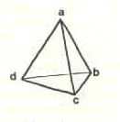 This initial attempt to diagram thought processes led Fuller to wonder how many events were needed to create ‘insideness’ and ‘outsideness’, which are Fuller’s characteristics of a system. Starting with two points, we see a space that lies between these two points. The addition of a third point that is not collinear with the other two defines a plane. Now when we add a fourth point that is not coplanar with the other three, we have divided space into two sections that which lies inside the four point system, and that which is outside. Thus, we have created the minimum system, with four events (points), and six relationships (edges), specifically a tetrahedron.
The tetrahedron becomes the primary structure used by Buckminster Fuller. It is, essentially, the building block of nature’s coordinate system.

I will now describe Fuller’s ‘coordinate system’ of nature, which has been mentioned previously. Imagine a layer of equilateral spheres lying side by side, so that each sphere is touching four others at a single point. Now lay another row of spheres on top of the first layer so that each sphere lies in a cavity between four lower spheres. As we continue this indefinitely, we are filling space with spheres, in the most tightly packed fashion. Now, imagine interconnecting all the centers of the spheres, and then eliminating the spheres. We now have a symmetrical, repetitive grid which Fuller calls the ‘Isotropic Vector Matrix (IVM). 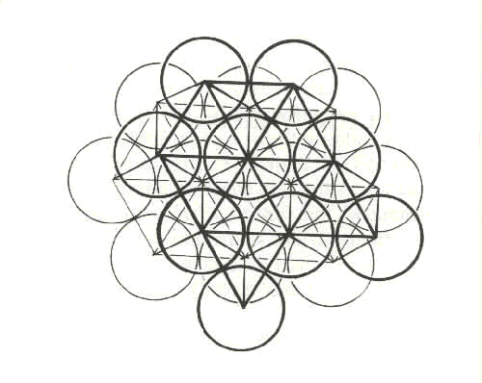Notice that the basic polyhedra that make up the IVM are alternating tetrahedra and octahedra. We can also see higher frequencies of each type of polyhedra. That is, there are polyhedra of various sizes which retain the same structure and shape.
Thinking in terms of systems is crucial in Fuller’s mathematics. We can isolate infinite subsystems with the IVM, which include a variety of repeating polyhedra. Fuller states that geometry is the study of relationships. The relationship between the parts of a system, and their surrounding environment is evident in the IVM, as well as the universe.
A key idea of this new form of synergetic geometry is that area and volume are presented as countable quantities, as opposed to a continuous space. We are able to count the volume of any polyhedron in the IVM by counting the individual tetrahedra inside.
Contrary to conventional mathematics, the IVM does not contain any central origin. All of the vertices of the system are equal, and the entire matrix is symmetric. In addition, Fuller’s geometry does not operate on a basis of 90 degrees, but rather 60 degrees. Every tetrahedron that makes up the IVM has interior angles of 60 degrees.

The Isotropic Vector Matrix has led to three primary inventions of Buckminster Fuller. The first of these is the octet truss. This structural element is so widespread in modern architecture that one assumes that buildings were always constructed that way. This illustrates Fuller’s idea that we can use nature’s structural system to our advantage.
The most prolific of Fuller’s geometric inventions is the geodesic dome. If we visualize the concept on a flat surface, we can translate it into the third dimension easily. Begin with a triangle, which has three vertices. Progress to a square, with four vertices, and so on, through pentagons and hexagons. Eventually, as we have more and more vertices, the polygon begins to resemble a circle. Similarly, we can approximate a sphere by a polyhedron with many vertices. A geodesic dome is a structure that takes full advantage of the stability of triangles on the outer surface of this polyhedron.
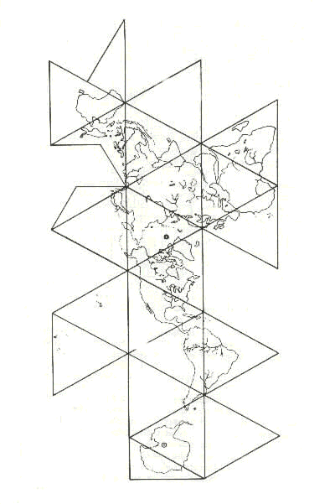 His third invention is a dymaxion map, which is a map of the world based on a geodesic approximation. It has great advantages over other projections of the globe onto a flat surface. For example, the Mercator projection greatly distorts the visual appearance of land masses as you approach the poles. On a Mercator projection, Greenland and Alaska look gigantic in comparison to South America and Africa. The dymaxion map minimizes this distortion, so that relative areas are preserved in translating the three dimensional globe onto a flat surface.
I’ll end with a statement which captures the essence of Fuller’s curiosity, and playfulness in creating his geometry of the order of the universe, “I did not set out to create a geodesic dome, I set out to discover the structures of the universe. For all I know, that could have led to a pair of flying slippers.”

Works Cited

Edmondson, Amy. “A Fuller Explanation.” Birkhauser Press. Boston, Massachusetts, 1987.

Fuller, Buckminster R. “Synergetics: the Geometry of Thinking.” MacMillan Publishing Co. Inc. 1979.

Hatch, Alden. “Buckminster Fuller at home in the Universe.” Crown Publishers Inc. New York, 1974.

